**HCMC UNIVERSITY OF TECHNOLOGY AND EDUCATION**

**Faculty of High Quality Training**

**Computer Engineering Technology**

**PRACTICE REPORT**

COURSE NAME:

COMPUTER ARCHITECTURE AND ORGANIZATION LAB

**WEEK 2**

**Course code:**

221COOL325364E

**Student:**

Pham Minh Long - 191190467

Ho Chi Minh City, 29 August 2021

OVERVIEW

There are 6 instruction sets that need to understand and broaden the horizon about other assignments.

**MOV: This is used to move/assign.**

Algorithm:

operand1 = operand2

Example:

MOV CL, 'A' ; CL = 41h (ASCII code).

**ADD: This is an addition operand.**

Algorithm:  
operand1 = operand1 + operand2  
Example:

MOV AL, 5 ; AL = 5

ADD AL, -3 ; AL = 2

RET

**SUB: This is a subtraction operand.**

Algorithm:  
operand1 = operand1 - operand2  
Example:

MOV AL, 5

SUB AL, 1 ; AL = 4

**MUL: This is multipication operand.**

Algorithm:

when operand is a **byte**:  
AX = AL * operand.

when operand is a **word**:  
(DX AX) = AX * operand.

Example:

MOV AL, 200 ; AL = 0C8h

MOV BL, 4

MUL BL ; AX

**DIV: This is a division operand.**

Algorithm:

when operand is a **byte**:  
AL = AX / operand  
AH = remainder (modulus)

when operand is a **word**:  
AX = (DX AX) / operand  
DX = remainder (modulus)

Example:

MOV AX, 203 ; AX = 00CBh

MOV BL, 4

DIV BL ; AL = 50 (32h), AH = 3

**INT21H: This is an interruption.**

**INT 21h** / **AH=1** - read character from standard input, with echo, the result is stored in **AL**.  
if there is no character in the keyboard buffer, the function waits until any key is pressed.  
example:

mov ah, 1

int 21h

**INT 21h / AH=2** - write the character to standard output.  
entry: DL = character to write, after execution AL = DL.  
example:

mov ah, 2

mov dl, 'a'

IMPLEMENTATION AND RESULT

There are 3 main assignments for the lab:

Problem 1: Adding and Subtracting two numbers which are less than 10 and the expected outputs which consist of the addition and subtraction operand are less than 10.

**Code for problem 1:**

mov ah, 1

int 21h; AL=34h number A

mov dl, al; dh is the 1st number

int 21h

mov dh, al; dl is the 2nd number

; summation 7+1=8

mov cx, dx ;dx for summation; cx for subtraction

sub dx, 3030h ;'7' 37h -> 07h ;'1' 31h -> 01h

add dl, dh

add dl, 30h

mov ah, 2

int 21h

mov dx, cx

sub dx, 3030h ;'7' 37h -> 07h ;'1' 31h -> 01h

sub dl, dh

add dl, 30h

mov ah, 2

int 21h

**Result for problem 1:**

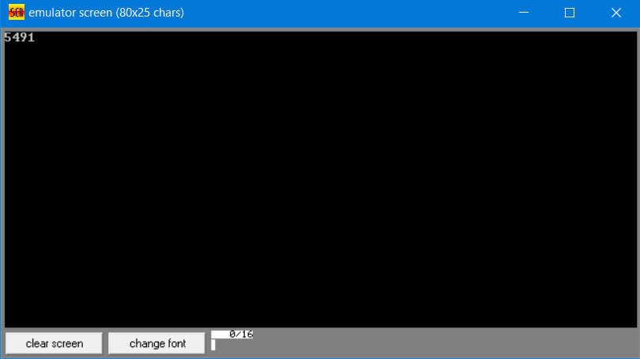

Problem 2: Adding and Subtracting two numbers which are less than 10 and the expected outputs which consist of the addition and subtraction operand are both greater than 10.

**Code for problem 2:**

;----------------------- Nhap so thu nhat luu vao bl

mov ah,1

int 21h

sub al,30h

mov dh,10

mul dh

mov bl,al

;----------------------- Nhap so thu 2 luu vao bh

mov ah,1

int 21h

sub al,30h

mul dh

mov bh,al

;----------------------- Luu tong vao cl,ch

mov ax,bx

add al,ah

mov ah,0

div dh

mov cx,ax

mov ah,0

div dh

mov cl,ah

;----------------------- In ra man hinh

mov ah,2

mov dl,al

add dl,30h

int 21h

mov dl,cl

add dl,30h

int 21h

mov dl,ch

add dl,30h

int 21h

;----------------------- luu hieu vao bl,bh

mov ax,bx

sub al,ah

mov ah,0

div dh

mov bx,ax

;----------------------- In ra man hinh

mov ah,2

mov dl,bl

add dl,30h

int 21h

**Result for problem 2:**

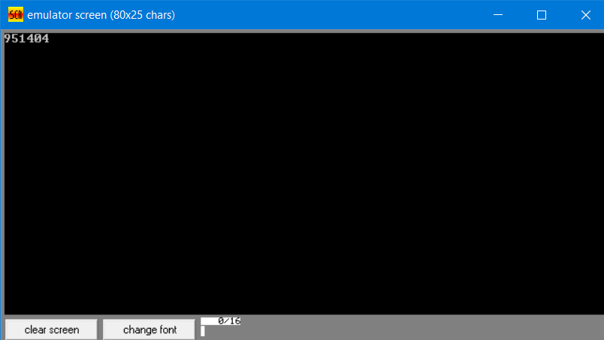

Problem 3: Adding and Subtracting two numbers which are greater than 9 and the expected outputs which consist of the addition and subtraction operand are both greater than 9.

**Code for problem 3:**

;----------------------- Nhap so thu nhat luu vao bl

mov ah,1

int 21h

sub al,30h

mov dh,10

mul dh

mov bl,al

mov ah,1

int 21h

sub al,30h

add bl,al

;----------------------- Nhap so thu 2 luu vao bh

mov ah,1

int 21h

sub al,30h

mul dh

mov bh,al

mov ah,1

int 21h

sub al,30h

add bh,al

;----------------------- Luu tong vao cl,ch

mov ax,bx

add al,ah

mov ah,0

div dh

mov cx,ax

mov ah,0

div dh

mov cl,ah

;----------------------- In ra man hinh

mov ah,2

mov dl,al

add dl,30h

int 21h

mov dl,cl

add dl,30h

int 21h

mov dl,ch

add dl,30h

int 21h

;----------------------- luu hieu vao bl,bh

mov ax,bx

sub al,ah

mov ah,0

div dh

mov bx,ax

;----------------------- In ra man hinh

mov ah,2

mov dl,bl

add dl,30h

int 21h

mov dl,bh

add dl,30h

int 21h

**Result for problem 3:  
